Portfolio Profect

Jordan LaCerte

June 7, 2020

CSU Global

Air Pollution and Asthma

With the myriad of issues in today’s society, one of the most pressing is the existential issue of climate change. One of the major effects of climate change is major air pollution that can possibly be deadly. According to the World Health Organization, “The combined effects of ambient (outdoor) and household air pollution cause about seven million premature deaths every year, largely as a result of increased mortality from stroke, heart disease, chronic obstructive pulmonary disease, lung cancer and acute respiratory infections” (World Health Organization 2020). With nearly 7 million deaths a year due to air pollution and its complications, it is an imperative problem that should be of higher importance. This is especially true with another deadly disease,COVID-19, roaming, which can be exacerbated by the effect of air pollution and its complications. As COVID-19 is a respiratory illness that specifically weakness the immune system and respiratory system, people living in areas with high amount of air pollution could be a major disaster waiting to happen. Finally, personally living in Colorado and having lived in China for a good period of my life, I have a personal interest in looking at the effects of clean air on the health of people as both have had issues with air quality to say the least. In order to look at the relationship between air quality and personal health, it was important to look at the trends of the most common respiratory diseases, namely asthma and lung disease. Asthma and lung diseases are some of the most noticeable and devastating effects of poor air quality on humans.

In order to perform this experiment, it was important to get the right data from the right sources. There are two questions that this is aiming to answer, whether there has been any change positive or negative in air quality in the US, and whether the rates of certain respiratory illnesses has changed overtime. The air quality data is from the Environmental Protection Agency and the lung disease data is from the Center for Disease control. All of the data is from these two government agencies that are usually considered highly reputable, and their data is usually considered spot on. The lung disease that has a direct correlation with poor air quality is asthma. According to the Asthma and Allergy Foundation of America, air pollution can worsen asthma symptoms, and potentially cause people to develop asthma if exposed repeatedly to dangerous amounts of ozone (Asthma and Allergy Foundation of America 2015). Therefore, asthma rates are a good measure of overall lung and respiratory health of a population.

The data received from the EPA on air quality is a Microsoft Excel CSV file that has 19 columns and 341 rows including headers. The rows include the City/State, core bases statistical area (CBSA) code, year, days with AQI, good/moderate/unhealthy/etc. air quality, days with dangerous levels of NO2, Ozone, SO2, parts per million above 2.5, and parts per million above 10. The file from the CDC on asthma rates is copied from the EPA website, and it includes 3 columns and 51 rows including headers. The columns are the state, the number of people currently afflicted with asthma, and the percent of the population currently afflicted with asthma. The CDC data was very clean and required no data cleaning for the 2014 file, the 2018 file required splitting the percent column into two columns. The EPA data involved various large cities in states, so it needed to be molded in order to work with. The data cleaning was fairly small, all that was needed was to group the data by state instead of having it individually by city. In order to do this, the city/state column was split using Excel’s text to column to split by comma, and then using R to group the remaining rows by state. As stated previously, ozone is one of the gasses most responsible for respiratory issues and for asthma, so ozone will be the measure for how good a state’s air quality is. With these two measures figured out, the next step is to figure out what the question is.

Therefore, our question is whether or not there has been a significant change in both air quality and in asthma rates in the United States. In order to measure if there is a significant change in ozone rates and asthma rates, a two sample t-test will be used on air quality data and asthma data from 2014 and 2018 as the asthma database only goes back to 2014. The main prediction is that both air quality and asthma rates are significantly worse in 2018 than they were in 2014. One of the main reasons for that is the current administration rolling back previously set EPA guidelines and generally gutting environmental issues compared to the previous administration. Additionally, environmental and air pollution issues tend to compound if little is done to combat them.

A two sample t-test was conducted using R. The two null hypothesis are that there is no significant difference in means between the 2014 and 2018 rates in asthma and average number of days with high ozone levels respectively. The R code is posted below.



The results of the above R code are in the image below.

Air Quality – 2014 is X and 2018 is Y.



Percent of population with Asthma – 2014 is X and 2018 is Y.

From running the t-tests, we can conclude that we reject the null hypothesis, it appears there is a significant difference in means from 2014 and 2018 in factors related to air pollution. Additionally, it appears that there is a stark difference between 2014 and 2018 in these issues related to clean air. With a p-value as high as 0.2478, it suggests that there is almost no way that 2018 levels of ozone and 2014 levels could be similar. For the difference in mean days with high levels of ozone, the confidence interval was from -32.89546 to 8.54171. With a range this wide, it appears that 2014 had a much lower level of days with high levels of ozone. It is a similar story with asthma rates, but it is not as dramatic a difference. The p-value for asthma rates is 0.1393 and the confidence interval is from -0.9280711 to 0.1318447. Like air quality, this suggests that asthma rates were down in 2014 as compared to 2018.

In order to explore this more and to try and visualize this phenomenon, it is important to create some charts with the data at hand. The below maps show the 2018 and 2014 average days with high levels of ozone and 2018 and 2014 percentage of the population that had asthma respectively.

2018 Days with High levels of Ozone per state

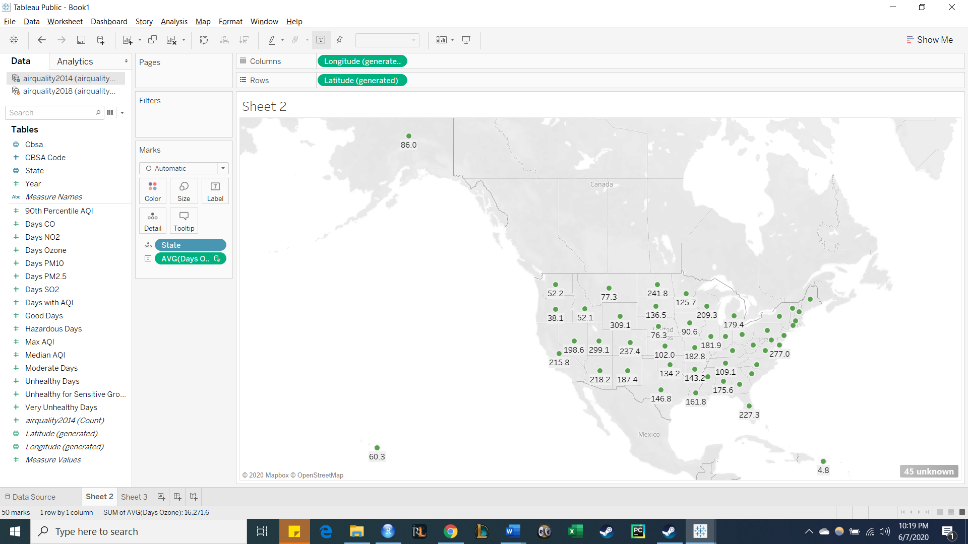

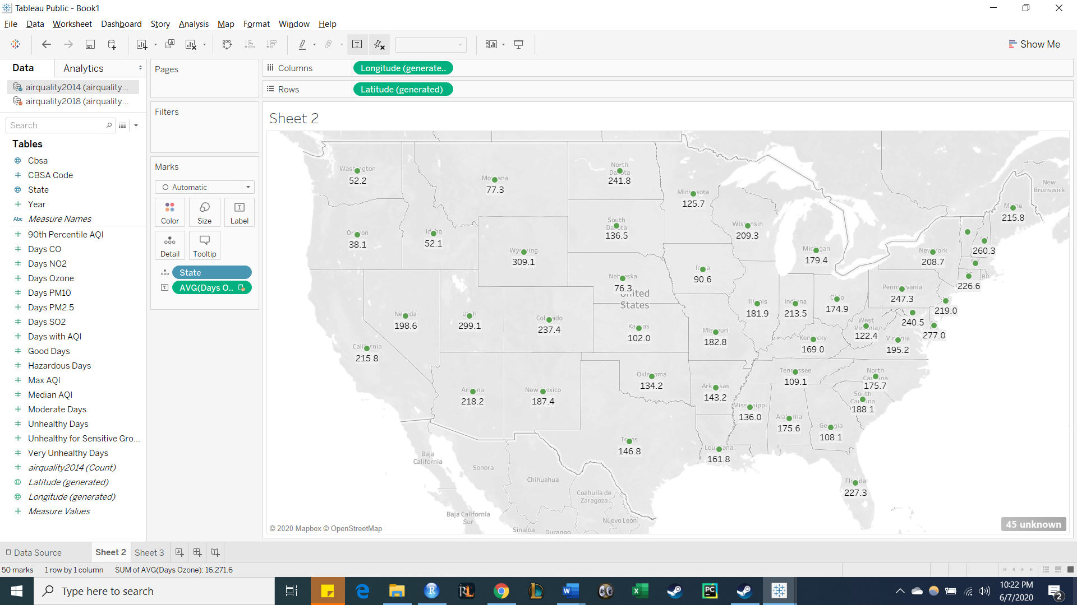

2014 Days with High Levels of Ozone Per state

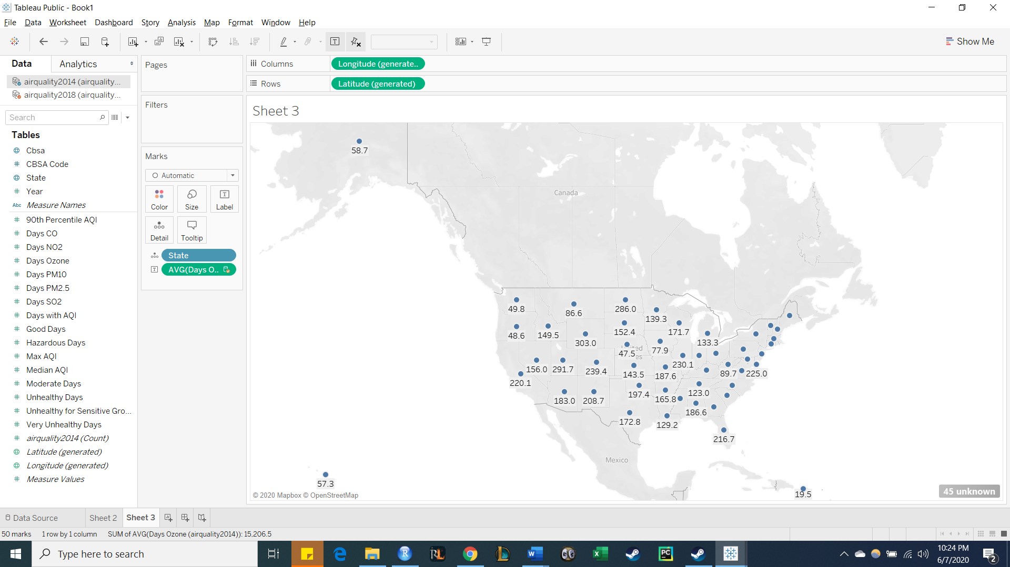

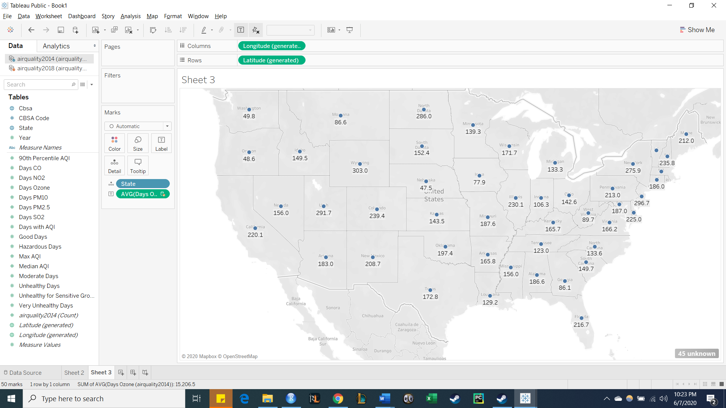

2018 Percent of Population with Asthma

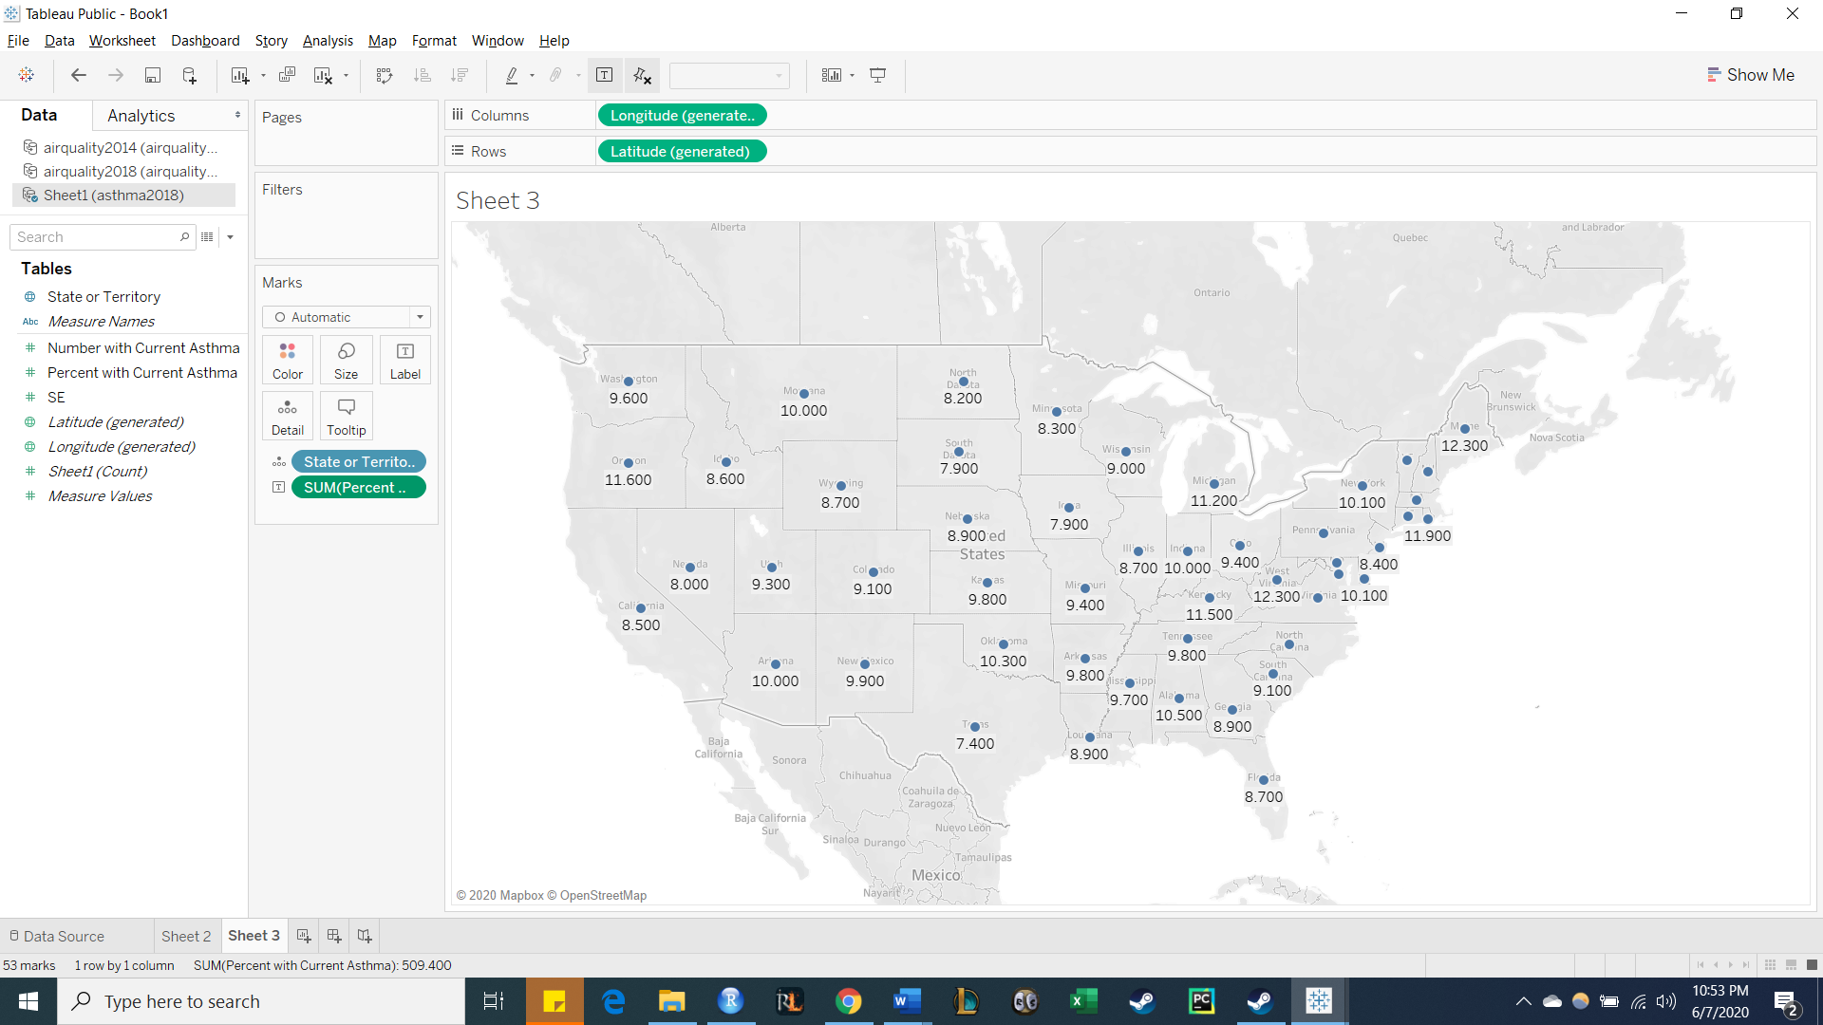

2014 Percent of Population with Asthma

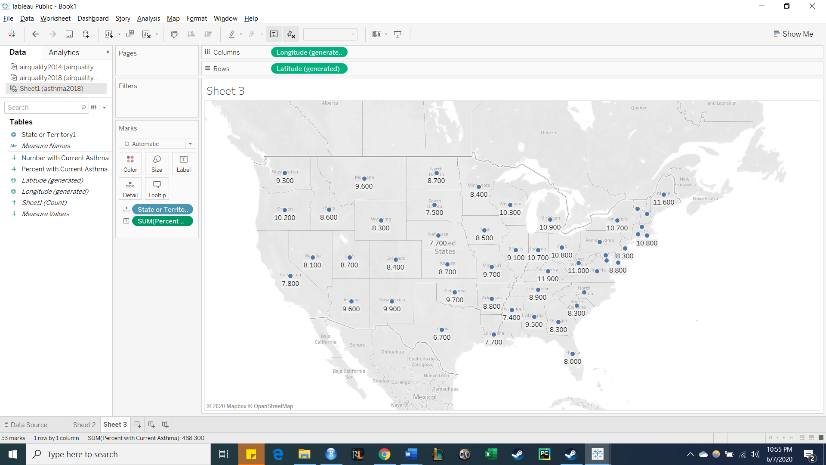

As we can see from the maps above, they roughly correlate with each other. Generally, areas in the traditional “rust belt,” the south, and mid-Atlantic tend to have higher levels of both asthma and ozone. Another trend we can see that confirms out t-test, is that it seems that 2018 in both sets of charts generally has more air quality issues and consequences from those than 2014 does.

One of the largest reasons for the increase in air pollution, and the harsh side effects from it, are the differences in priority from the two administrations. While it can be argued that the previous administration did not place air quality as a priority, the current administration has issued rollbacks, cuts, and installed dangerous and unqualified people in charge of key environmental agencies. Just recently, the head of the EPA, Andrew Wheeler, will not impose stricter measures on various lung damaging particles, which could cause irreversible damage (Coral Davenport 2020). While some may deny the overall impact of climate change, looking at the data shows that the United State’s air quality has gone down since 2014, and with current plans to roll back clean air protections further, it appears that respiratory illnesses could increase and could become more dangerous as breathing poor air only exacerbates these issues. As we can see from the t-test performed on both air quality and asthma rates, it shows that air quality has gone down, and asthma has gone up. For further endeavors, it would be prudent to look at a wider variety of respiratory illnesses to see if maybe asthma is being diagnosed differently which could lead to increased rates. Additionally, looking at data on a more micro level to see specific regions, look at urban vs rural air quality and respiratory disease, or other demographic information could be very useful.

References

Center for Disease Control, (2020, March 24) Most Recent Asthma State or Territory Data Retrieved June 7, 2020 from <https://www.cdc.gov/asthma/most_recent_data_states.htm#source>

Center for Disease Control , (2018, May) 2014 Archived State or Territory Asthma Data. Retrieved June 7, 2020 from <https://www.cdc.gov/asthma/archivedata/2014/2014_data_states.html>

Davenport, Coral (2020, April 14). ‘Unbelievable’ Timing: As Coronavirus Rages, Trump Disregards Advice to Tighten Clean Air Rules Retrieved June 7, 2020 from <https://www.nytimes.com/2020/04/14/climate/coronavirus-soot-clean-air-regulations.html>

Environmental Protection Agency (2020, May 19th). Pre-Generated Data Files. Retrieved June 7, 2020 from <https://aqs.epa.gov/aqsweb/airdata/download_files.html>

World Health Organization. <https://www.who.int/health-topics/air-pollution#tab=tab_1>